Please Help Us Make a Difference!!!

All Paws on Deck! We need your help –Pledge us or walk with us as we walk to make a difference!
Please pledge for Happy Tails Rescue at:
http://www.canadahelps.org/GivingPages/GivingPage.aspx?gpID=2040
You can also join Happy Tails Rescue to walk with us by downloading the pledge and registration form below. You are encouraged to pre-register and indicate your support for us at the site below. Please note that we are listed as Happy Tails All Breed Rescue, which is a printing mistake. If you choose to print off the pledge form, please circle Happy Tail Rescue as the group you are supporting:

http://www.rescuemewalk.com/GENERIC-LETTER-Pledge.pdf
Supporters of the Happy Tails Rescue group will be walking in the 6th Annual Walk-a-thon, and they need your help! They are working really hard to raise pledges for all their furry friends who don’t yet have a great forever home!
Happy Tails Rescue has joined forces with the registered charity K-9 Rescue Me which helps to financially support Ontario Canine Rescue Organizations. Over the past 6 years the groups that work together under the K-9 Rescue umbrella have saved 1000’s of dogs from being abandoned, abused & neglected, and spent millions of dollars for the veterinary and general care for these dogs on their journey to their forever homes.
The 6th Annual K-9 Rescue Me Walk-a-thon is to be held on June 14th during the Woofstock Event which is only weeks away! Woofstock & Walk-a-thon Schedule of Events:
Woofstock runs for 2 days Saturday, June 13th & Sunday, June 14th from 9am to 6pm. You can check out all the events that will happen at Woofstock at www.Woofstock.ca
Here are some of the reasons why your pledge support in the 2008 K9 Rescue Me Walk-a-thon will make such a difference in a Rescue Dogs life.....
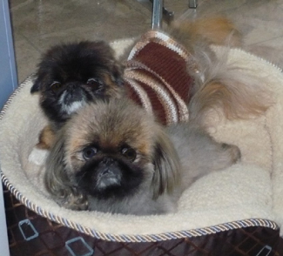
Yin and Yang , a pair of Pekinese brothers, who were found living in an apartment faithfully keeping watch at the side of their deceased owner. Yin had congenital deformities and Yang had a broken jaw. Both were frightened , alone and so matted that heir coats had to be shaved off. Dentistry and medical treatment for these two to get back on their feet…$1000+
Loki, an 11 year old deaf Bichon was no longer wanted by his former owners. He suffered from cherry eye, needed dentistry and had bladder stones that needed removal. Medical treatment to get him ready for his new home …$1600
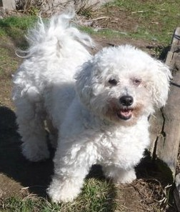
Tiara, a senior Shih Tzu with a loving temperament, was pulled from a shelter where everyone passed her by because of her neglected state. She received much needed dentistry and a spay…$900
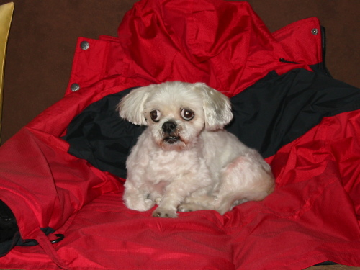
Max, a 5 year old Maltese who has been deaf since birth and has limited sight due to a cataract in one eye. The possibility of a cataract forming in the other eye is very real. Surgery to remove the cataract and give him a chance to lead the kind of life that a dog his age should be living…. $3000
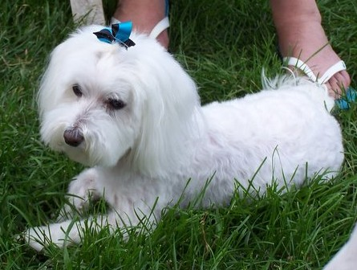
Bubbles and Pebbles, two senior sisters who had such terrible dental disease that it has compromised their liver function. Their aching mouths were cleaned up and they were restored to a healthy enough state that caring adopters were moved to take these two waifs in and give them the care and love that they deserved....$1700
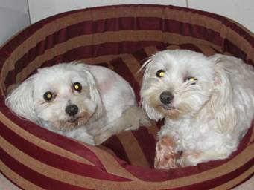
Happy Tails Rescue has also helped out a few Senior dogs to have a long over-due check-up and easing some of the aches and pains. Allowing them to live out their days in a permanent foster home so that their last memories are not of pain and loneliness but of love and comfort …. $500 +

Seeing Their Tails Wag for the First Time...Priceless
Don't do it for us. Do it for them. Without us they would have nothing.
We are pleased to announce that Beaches Animal Hospital, 2304 Queen Street East Toronto, ON M4E 1G8 - (416) 690-4040, , the clinic that has supported over 100 of our rescue pups, has been generous enough to sponsor us at the $4,000 level this year .Without their support , as well as all of our other well-wishers, we would not be able to help so many needy dogs.


Feel free to cross post this to any others that you think may be interested in giving a rescue dog a second chance.

