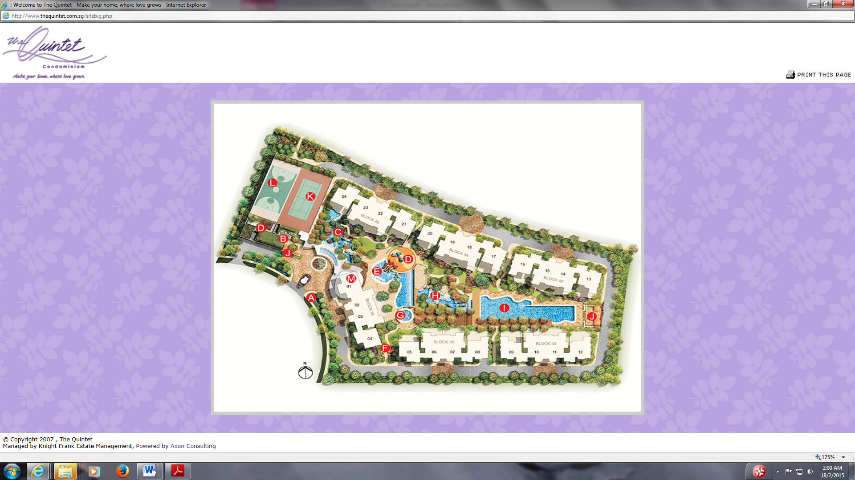

My Block & Unit, 12 Sty

Panoramic view side of the planter/balcony and full windows in BR2 and MBR that face opposite block and swimming pool



North-East 50 Degrees, NE2

Due to irregularities, I extended the sides to form one whole rectangle. 2 lines are drawn to each corner to find the intersection point as center of the home.From there, I take the compass direction at the facing of the panoramic view side of the planter/balcony and full windows in BR2 and MBR.

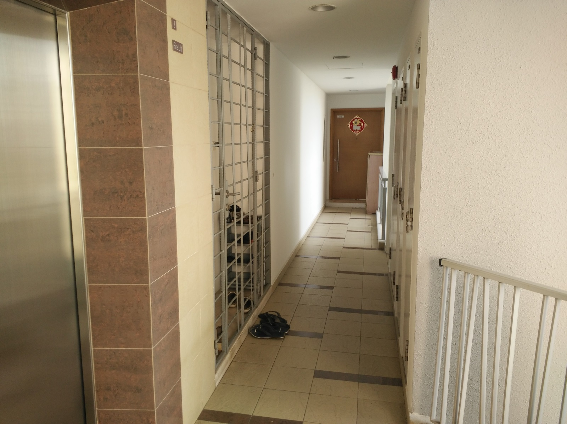

M&E Stack ( Starhub, Singtel , SP Services etc. ) right infront of main door.

My unit

