Training Strengths Inventory Profile
Megan
Feb 18 2015

Introduction to the Training Style Inventory
This profile is designed to help you understand your 4MAT Training Style Inventory (TRSI) results. Based on your responses, the TRSI assessment generates results to identify your score in four primary training strengths. Your Training Style represents your preference in four key training roles: facilitator, presenter, coach and evaluator.

Your Training Style Inventory Results
Your Highest Strength: 3
Your Least Preferred Quadrant: 4
Visit your TRSI results page to print your Training Strengths Graph.

Sample 4MAT Training Style Inventory Results Graph
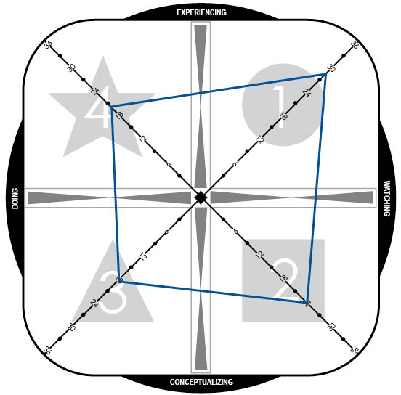
Your TRSI results are indicated by the four numbers which correlate to the four training style approaches. You receive a score in each of the four training styles on a scale of 0-36. In the example above, this individual has a high strength in 1 (Facilitator) and a secondary strength in 2 (Presenter). The weakest focus is on 3 (Coach). Your graph which shows your level of preference for each of the four roles on a scale of 1-36.

The Four Training Styles
The visual below provides an overview of all four of the 4MAT Training Styles. You will find more information on the strengths of each style in the following pages.
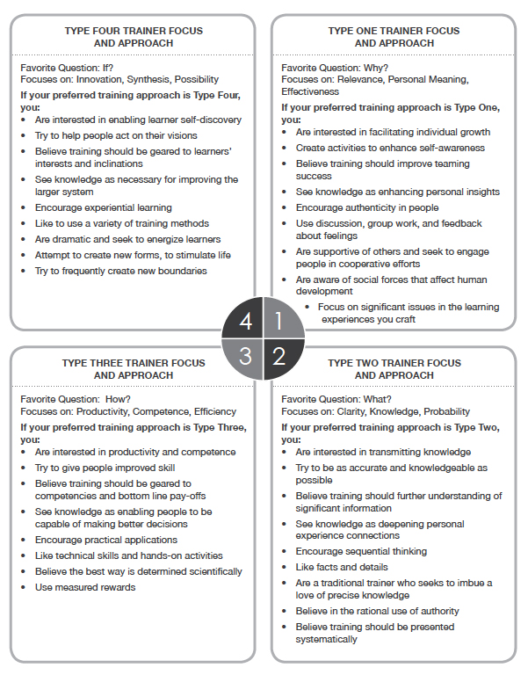

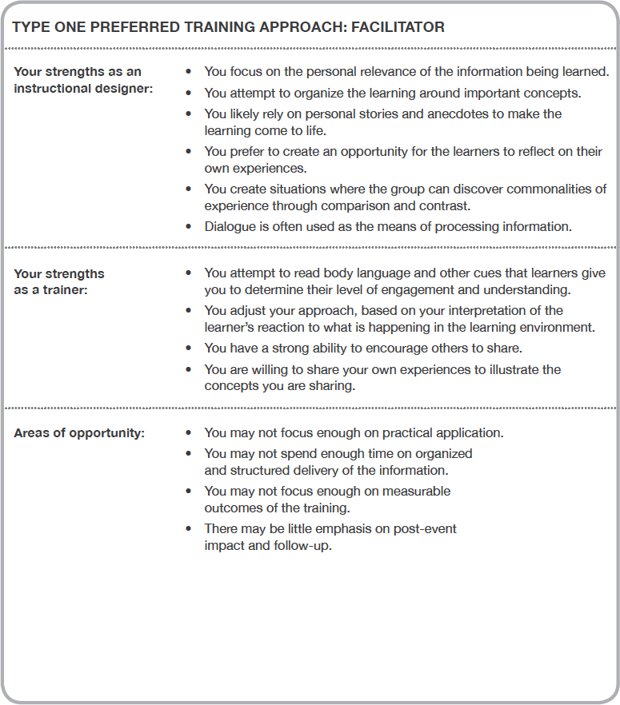

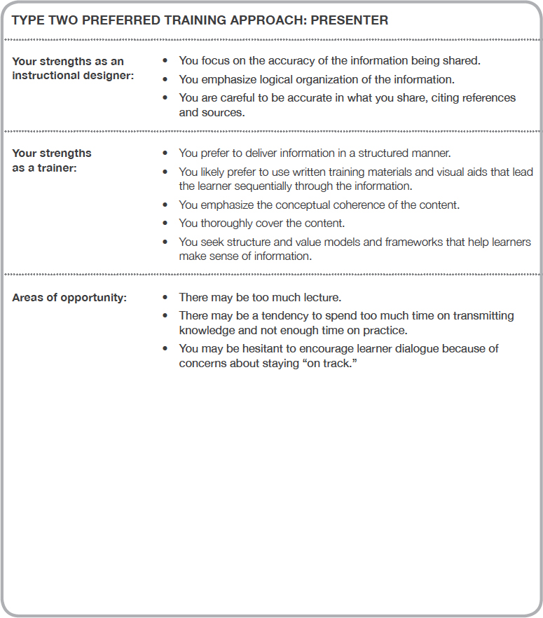

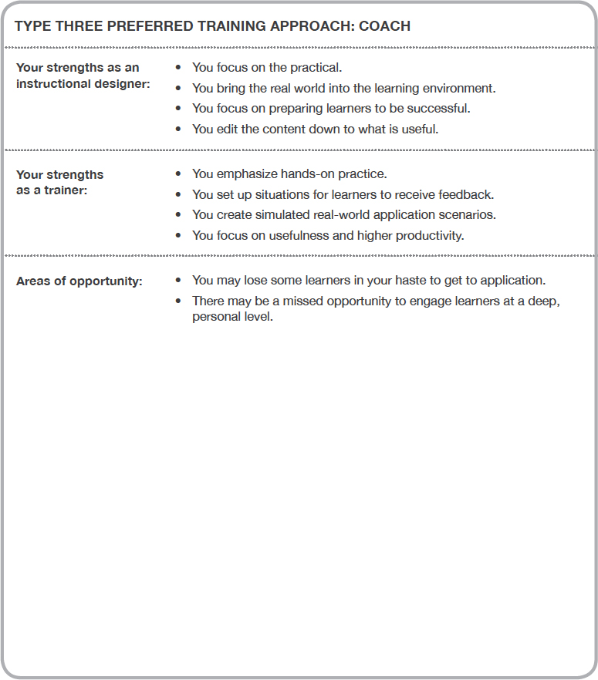

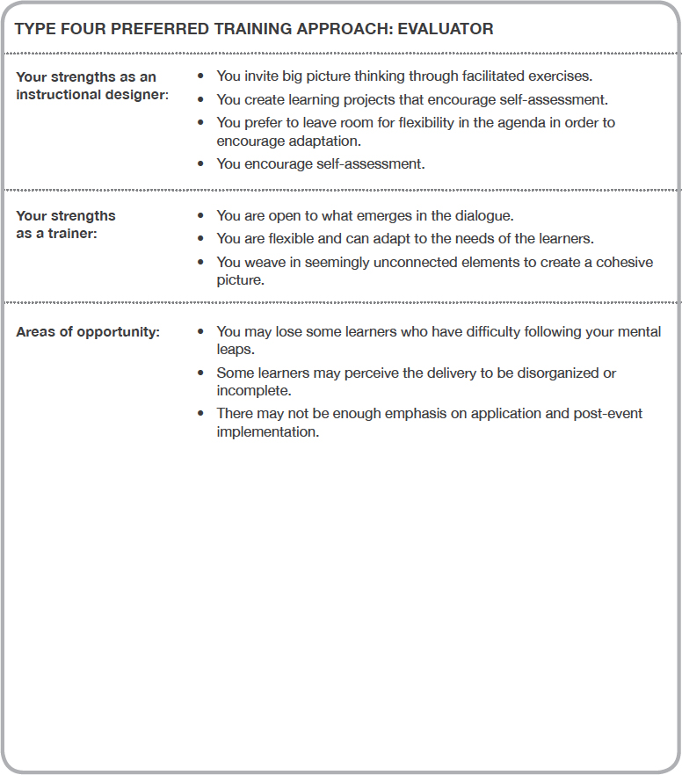

The 4MAT Learning Styles
Big Ideas
There are four primary preferences for how people like to take in and make meaning of new information, which we call learning styles.
Regardless of learning style, all learners move through a four-part cycle of learning when taking in and making meaning of new information.
Your natural training style strengths indicate which parts of the cycle you are most comfortable leading.
Your training style and learning style may be different.
The 4MAT Learning Type Measure (LTM) is one of the most widely used tools in the world for profiling individual approaches to learning. It measures individual preferences for selecting, organizing, prioritizing and representing knowledge, information and experience. To order, visit our website at www.4mat4business.com.

Learning style refers to the part of the learning cycle that you enjoy the most. It is the way that you prefer to experience and process information. You may find that your learning style and training style are different. The four primary learning styles are referred to as 1, 2, 3, 4.
While each of us has learning style preferences, we all move through the entire learning cycle. Here is an overview of the 4MAT Learning Styles descriptions:
Type 4: Dynamic Learners  - Seeks hidden possibilities  - Needs to know what can be done with things  - Learns by trial-and-error, self-discovery  - Enriches reality  - Adaptable to change and relish it  - Enjoys variety and excels in being flexible  - Risk-takers  - Often reaches conclusions without logic  Strength: action, carrying out plans  Goals: to make things happen  Favorite question: What if? | Type 1: Imaginative Learners  - Seeks meaning  - Needs to be personally involved  - Learns by listening and sharing ideas  - Absorbs reality  - Interested in people and culture  - Functions through social interaction  - Idea people  Strength: innovating and imagination  Goals: self-involvement in important issues, bringing unity to diversity  Favorite question: Why?
Type 3: Common Sense Learners  - Seeks usability  - Needs to know how things work  - Learns by testing theories using practical methods  - Edits reality  - Uses factual data to build concepts  - Enjoys hands-on experiences and problem solving  - Needs Ã¢ÂÅreal-lifeÃ¢ÂÂ correlation  Strength: practical application of ideas  Goals: bringing their view of the present into line with the future  Favorite question: How? | Type 2: Analytic Learners  - Seeks and examines the facts  - Needs to know what the experts think  - Forms reality  - Interested in ideas and concepts  - Critiques information, collects data  - Thorough and industrious  - Enjoys the traditional classroom  - Function by adapting to experts  Strength: creating concepts and models  Goals: self-satisfaction and intellectual recognition  Favorite question: What?

Your training approach naturally appeals to some learning styles more than others. We will explore how each style reacts to each training style approach.

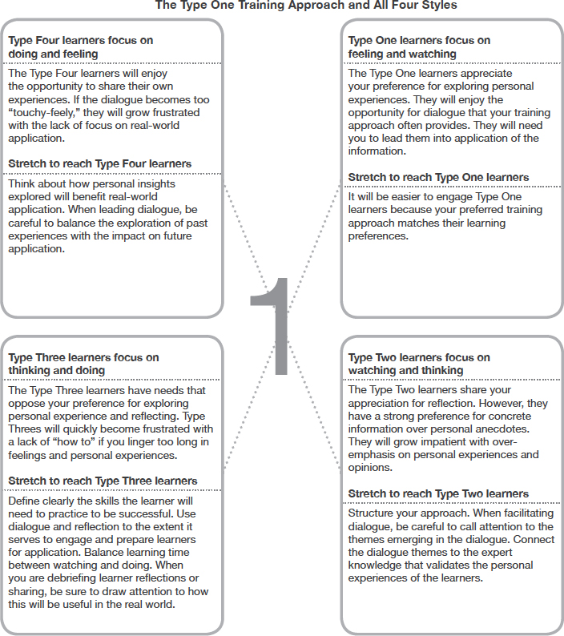

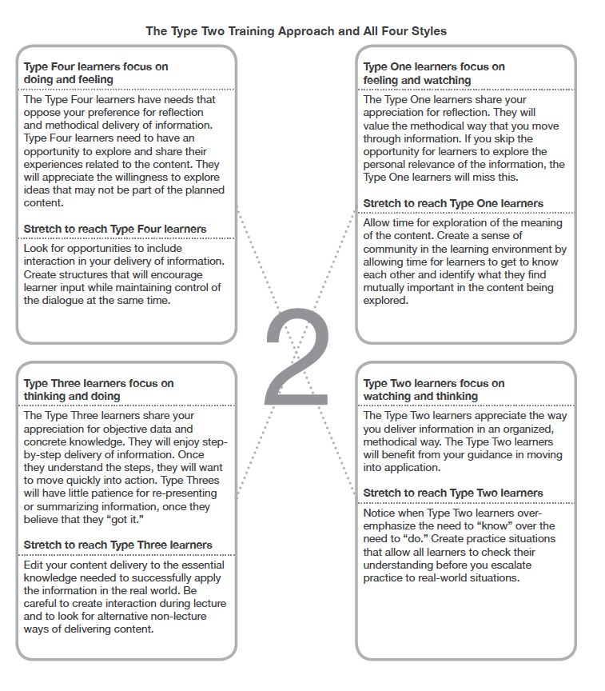

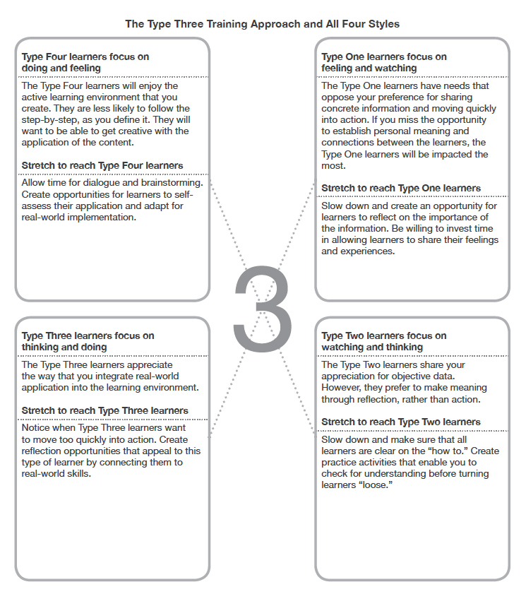

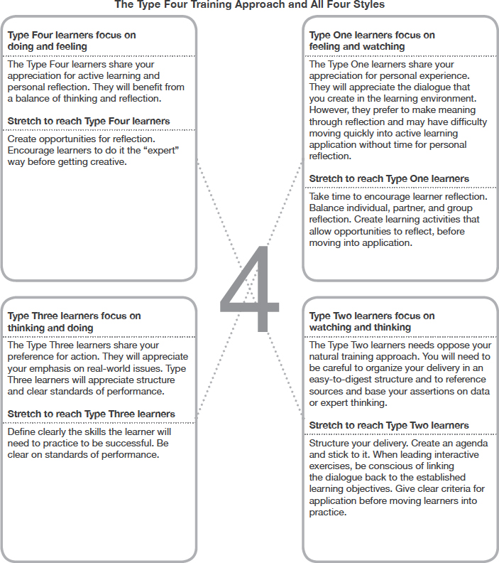

Skill Development Strategies
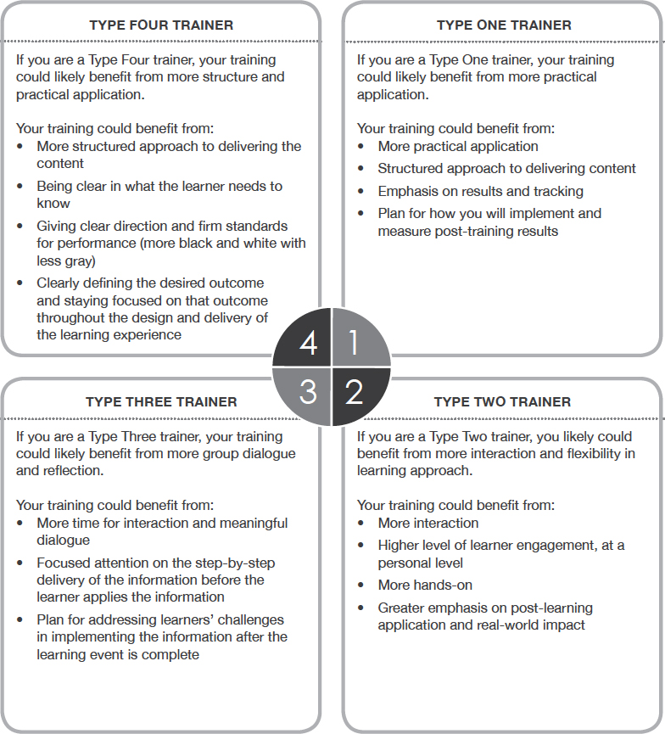

Next Steps/Learn More

Step 1 Identify Your Strengths
You have discovered your Training Style Strengths. You can also take the Learning Type Measure to identify your strengths in taking in and making meaning of new information. You will discover your thinking strengths along with how they show up in your role as a trainer, leader, parent, and more.

Step 2 Start With The Fundamentals
Engage, The Trainer Guide to Learning Styles explores how to build on your natural training strengths and build skill in weaker areas. Complete the Reflect and Act sections at the end of each chapter. If you work with a team of learning professionals, create a book study group and review each chapter together. You will find a book study guide on the companion site for Engage at www.trainers-guide-to-learning-styles.com.

Step 3 Invest In Yourself
Take time to explore the companion site to Engage, where you will find downloadable resources and FREE web events focused on applying the strategies shared.

Some of what you will find:
- Free web events and advanced course schedule
- Videos
- Downloadable tools

Step 4 Continue To Grow Your Skill
Join learning expert Jeanine ONeill-Blackwell and the 4MAT team in an advanced live or
web-based course to practice, apply, and master the application of 4MAT to training design and delivery. We can come to you, or you can join one of our open courses. Grow and expand your skill by becoming certified to lead one or all of the 4MAT course offerings within your organization.

Some of our courses include:
- Advanced Instructional Design
- 4MAT 4Leadership
- 4MAT 4Coaching
- Leading the Needs Analysis Process
- 4MAT 4Teams
- Visit www.4mat4business.com

